LAB ASSIGNMENT 1: DOCKER INSTALLATION, DOCKER HUB REGISTRATION, AND NGINX CONTAINER DEPLOYMENT

Objective
The objective of this lab is to:
- Install Docker Desktop successfully.
- Register a Docker Hub account using a college email ID.
- Verify Docker installation using Docker commands.
- Pull and run an Nginx container using Docker.
- Understand the complete Docker container lifecycle workflow.

Theory
- Docker: Docker is an open-source containerization platform that enables developers to package applications and their dependencies into lightweight containers. Containers ensure applications run consistently across different systems and environments.
- Docker Hub: Docker Hub is a cloud-based container registry service used to store, manage, and distribute Docker images. Developers can push their custom images to Docker Hub and pull images from anywhere.
- Nginx Container: Nginx is a high-performance web server commonly used for hosting websites and reverse proxy services. Docker allows Nginx to run inside isolated containers without requiring manual server configuration.
- Containerization: Containerization is a virtualization technique where applications run in isolated user spaces called containers. It improves portability, scalability, and deployment consistency.

Part 1: Download and Install Docker Desktop
Step 1: Visit Docker Official Website
- Open a web browser and visit the official Docker website: https://www.docker.com/
- Download Docker Desktop according to your operating system:
- Windows 10/11 (64-bit)
- macOS (Intel or Apple Silicon)

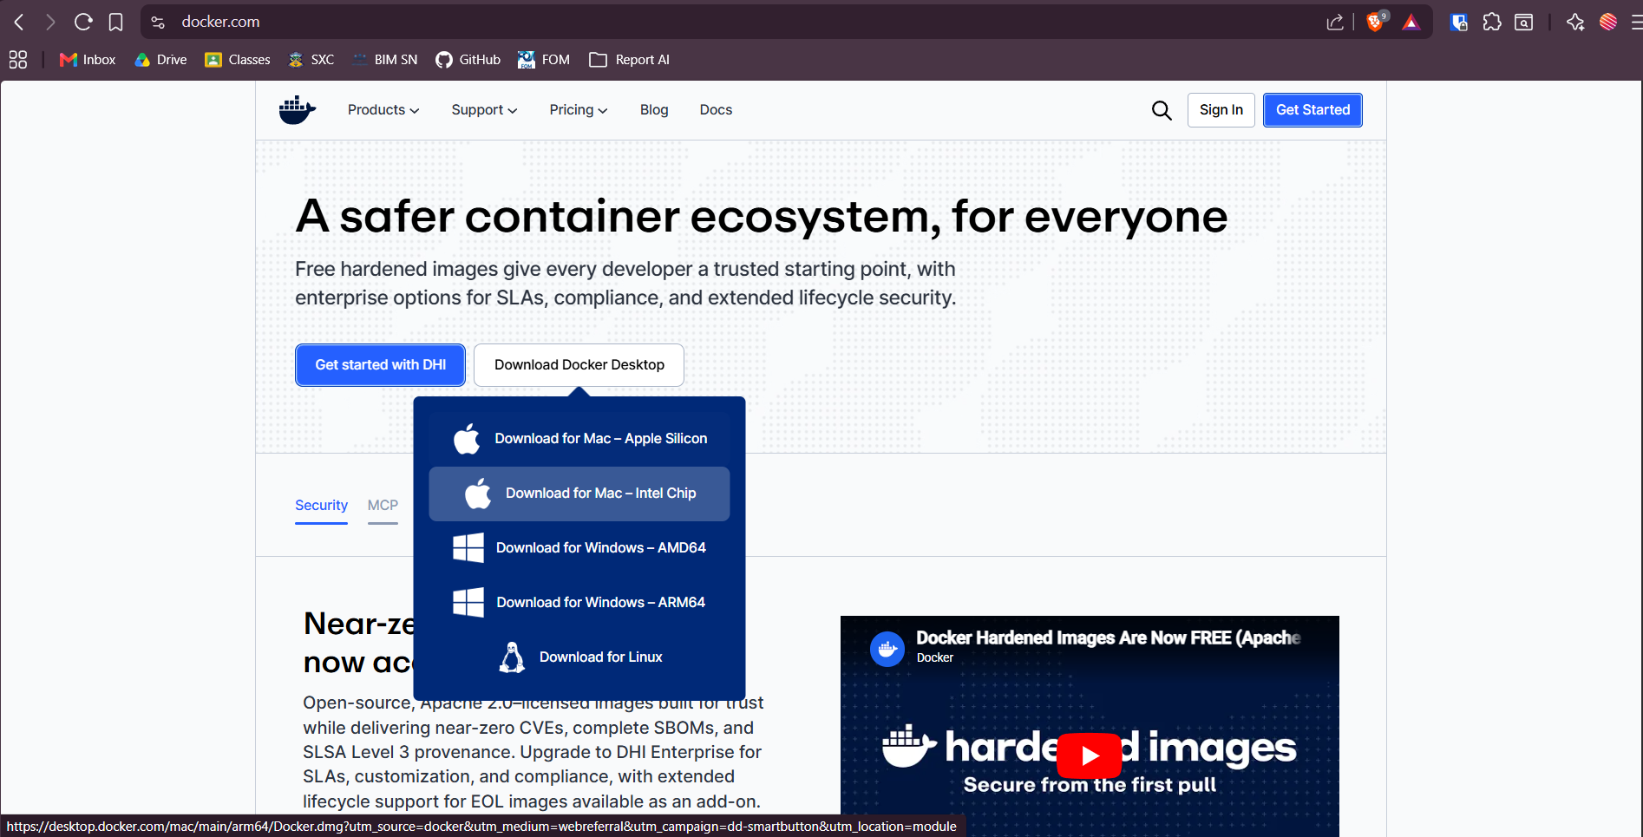
Figure 1.1 Docker official website

Step 2: Install Docker Desktop
- Run the installer and follow the installation process.
- For Windows:
  - Enable WSL 2 if prompted.
  - Complete all required configurations.
- Launch Docker Desktop after installation.

Step 3: Launch Docker Desktop
After installation, open Docker Desktop and verify that it launches successfully.
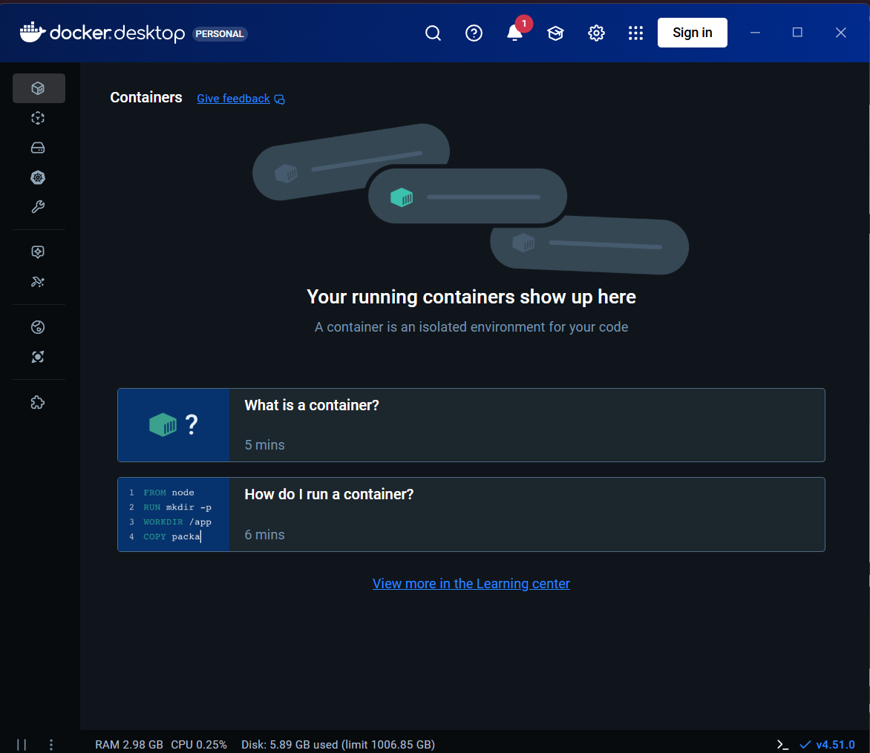
Figure 1.2 Docker desktop app in windows

Part 2: Register Docker Account
Step 1: Open Docker Hub
- Visit Docker Hub from the official Docker website.
- Click on the “Sign Up” button.
- Register using your official college email ID.

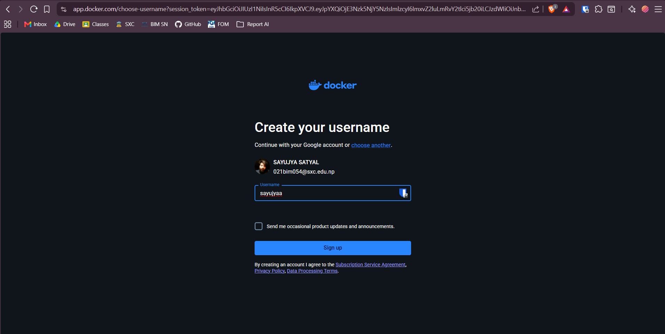
Figure 1.3 Signing in into docker hub

Step 2: Verify Email Address
Open your email inbox and verify your Docker account through the verification email.
Screenshot
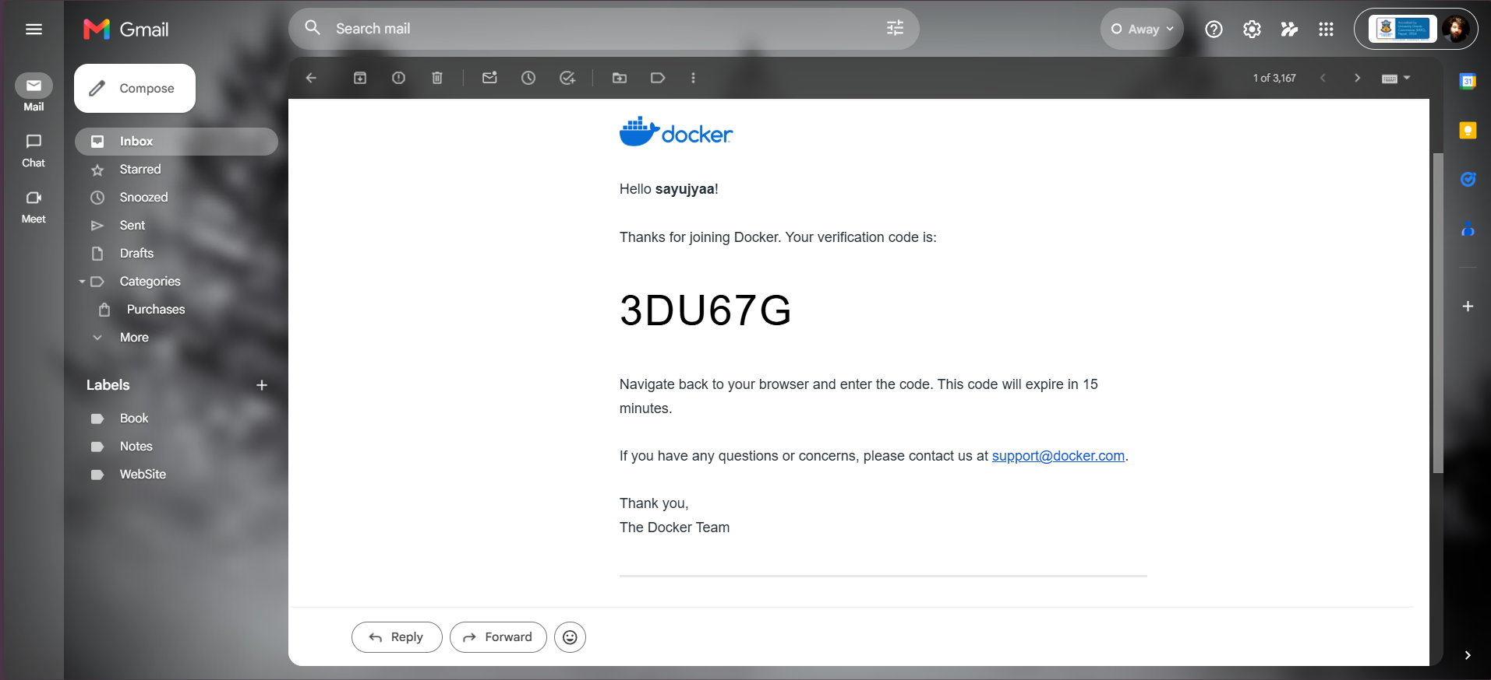
Figure 1.4 Docker otp during signup

Step 3: Login to Docker Hub
Log in using your Docker Hub credentials.
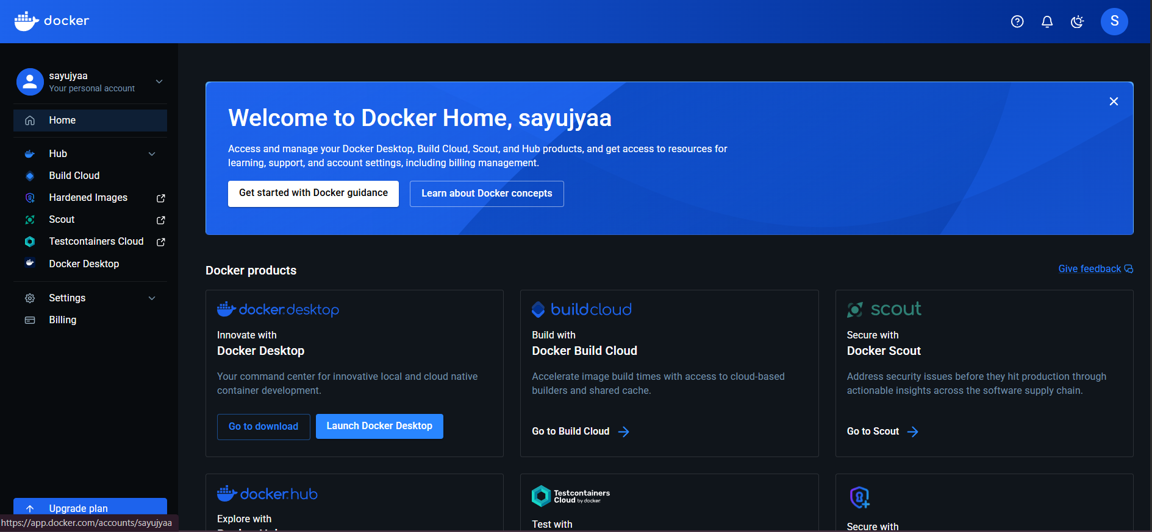
Figure 1.5 Successful signup in docker hub

Part 3: Verify Docker Installation
- Open Command Prompt
- Run the following command: docker --version
- This command verifies that Docker has been installed successfully.
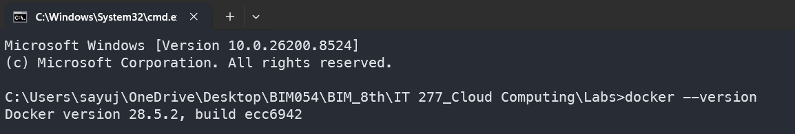
Figure 1.6 Docker installation verification

Part 4: Pull and Run Nginx Container
Step 1: Pull Nginx Image
- Run the following command: docker pull nginx
- Docker downloads the official Nginx image from Docker Hub.
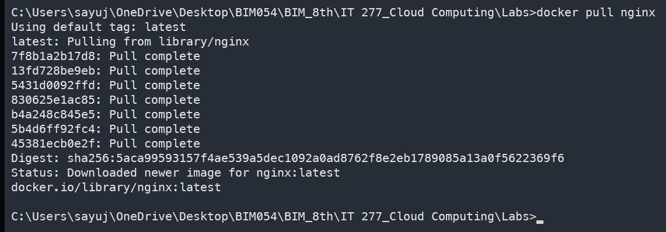
Figure 1.7 Pulling in the nginx image

Step 2: Create and Run Nginx Container
- Run the following command: docker run -d -p 8080:80 --name sayujya-nginx nginx
- Explanation:
- -d runs the container in detached mode.
- -p 8080:80 maps local port 8080 to container port 80.
- --name assigns a custom container name.
Figure 1.8 Create and run nginx container

Step 3: Verify Running Container
- Run the following command: docker ps
- This displays all currently running containers.
Figure 1.9 Verify the container is running

Step 4: Test Nginx in Browser
- Open a web browser and visit: http://localhost:8080
- The Nginx welcome page should appear successfully.
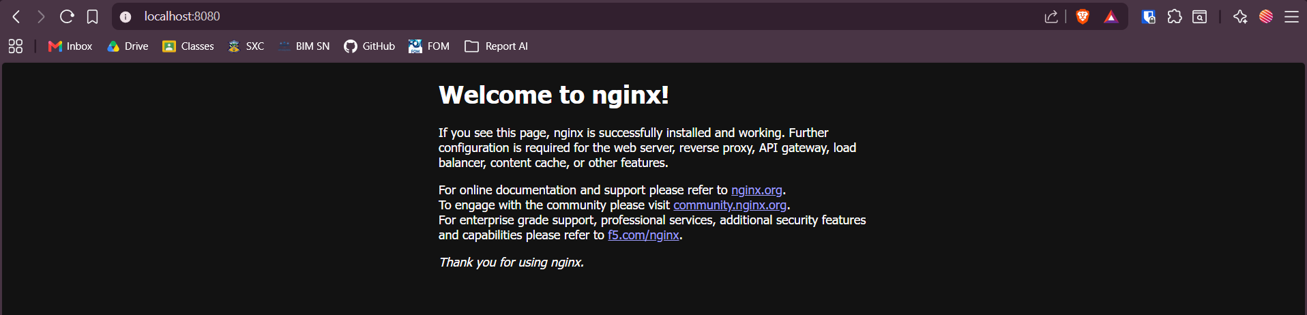
Figure 1.10 Nginx run test in browser

Step 5: Verify in Docker Desktop Dashboard
Open Docker Desktop and verify that the Nginx container is running.
Screenshot
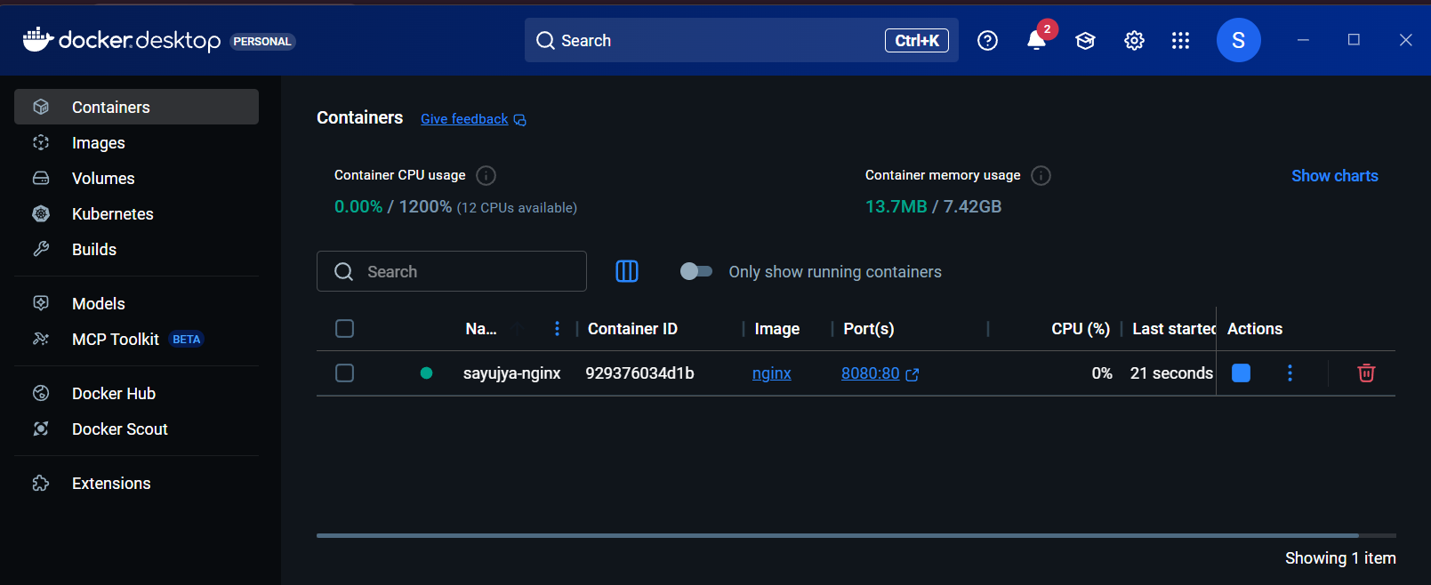
Figure 1.11 Final verification in docker desktop dashboard

Result
Docker Desktop was installed successfully. A Docker Hub account was created and verified using the college email ID. The Nginx Docker container was successfully pulled, executed, and accessed through the browser using localhost port mapping.

Conclusion
This lab provided practical knowledge about Docker installation, Docker Hub registration, Docker commands, container execution, and web server deployment using Nginx containers. The experiment demonstrated the basic workflow used in modern containerized application deployment.

Docker Complete Lifecycle Summary
  - Install Docker
Docker is first installed on the system to enable containerization.
Examples:
- Docker Desktop for Windows/macOS
- Docker Engine for Linux
Purpose:
To provide a platform for building and running containers.

  - Verify Installation
Commands used:
docker --version
Purpose:
To verify that Docker is properly installed and running.

  - Create Project
Create a project directory for application development.
Example:
mkdir myapp
cd myapp
The project may contain:
- Source code
- Dependencies
- Configuration files

  - Create Dockerfile
Create a file named Dockerfile.
Example:
FROM node:18
WORKDIR /app
COPY . .
RUN npm install
CMD ["node", "app.js"]
Purpose:
Defines how Docker builds the application image.

  - Build Docker Image
Command:
docker build -t myapp:v1 .
Explanation:
- -t specifies image tag
- myapp:v1 is image name and version
Check images using:
docker images

  - Run Container
Command:
docker run -d -p 3000:3000 --name mycontainer myapp:v1
Purpose:
Runs the application inside a container.

  - Test and View Logs
Test application in browser:
http://localhost:3000
View logs:
docker logs mycontainer
Purpose:
Used for debugging and monitoring.

  - Stop and Remove Container
Stop container:
docker stop mycontainer
Remove container:
docker rm mycontainer
Remove image:
docker rmi myapp:v1

  - Login to Docker Hub
Command:
docker login
Purpose:
Authenticate with Docker Hub registry.

  - Tag Docker Image
Command:
docker tag myapp:v1 username/myapp:v1
Purpose:
Prepares the image for pushing to Docker Hub.

  - Push Docker Image
Command:
docker push username/myapp:v1
Purpose:
Uploads image to Docker Hub.

  - Pull Image on Server
Command:
docker pull username/myapp:v1
Purpose:
Downloads the image to a production server.

  - Deploy Application
Command:
docker run -d -p 80:3000 username/myapp:v1
Purpose:
Deploys the application to production.

  - Rebuild New Version
Command:
docker build -t myapp:v2 .
Purpose:
Creates a new version after code updates.

  - Push Updated Version
Commands:
docker tag myapp:v2 username/myapp:v2
docker push username/myapp:v2
Purpose:
Uploads updated image version.

  - Redeploy Updated Application
Commands:
docker pull username/myapp:v2
docker stop oldcontainer
docker rm oldcontainer
docker run -d -p 80:3000 username/myapp:v2
Purpose:
Updates the running production application.

Docker Lifecycle Flow
- Development Machine: Code → Dockerfile → Build → Run → Test
- Docker Registry: Tag → Push
- Production Server: Pull → Run → Deploy
- Update Cycle: Modify Code → Rebuild → Push → Pull → Redeploy

Final Summary
Docker lifecycle follows a continuous workflow:
Build → Run → Test → Push → Deploy → Update → Repeat

Benefits include:
- Consistent environments
- Faster deployment
- Better scalability
- Simplified version control
- Easier application management

LAB ASSIGNMENT 2: DOCKERIZE A REACT PROJECT FROM GITHUB

Objective
The objective of this lab is to:
- Clone an existing React project from GitHub.
- Create a Dockerfile for the React application.
- Build a Docker image using Docker.
- Run the Docker container locally.
- Push the Docker image to Docker Hub.
- Learn the workflow of deploying React applications using Docker containers.

Theory
- React Application: React is a JavaScript library used for building interactive user interfaces and single-page web applications. React applications are commonly deployed using web servers such as Nginx or Apache.
- Docker Image: A Docker image is a lightweight, executable package containing application code, dependencies, libraries, and configurations required to run an application.
- Docker Container: A Docker container is a running instance of a Docker image. Containers provide isolated environments for applications.
- Nginx Web Server: Nginx is a high-performance web server used to serve static files and host frontend applications such as React production builds.
- Docker Hub: Docker Hub is a cloud-based registry used to store and distribute Docker images.

Requirements
- Docker Desktop installed
- Git installed
- Docker Hub account
- Existing React project hosted on GitHub

Part 1: Clone React Project from GitHub
Step 1: Open Terminal or Command Prompt
Open Terminal, PowerShell, or Command Prompt on your system.

Step 2: Clone the GitHub Repository
- Run the following command: git clone git@github.com:sayujyaa/portfolioV2.git
- Move into the project directory: cd portfolioV2

Explanation:
- `git clone` downloads the React project from GitHub.
- `cd` changes the current directory to the project folder.
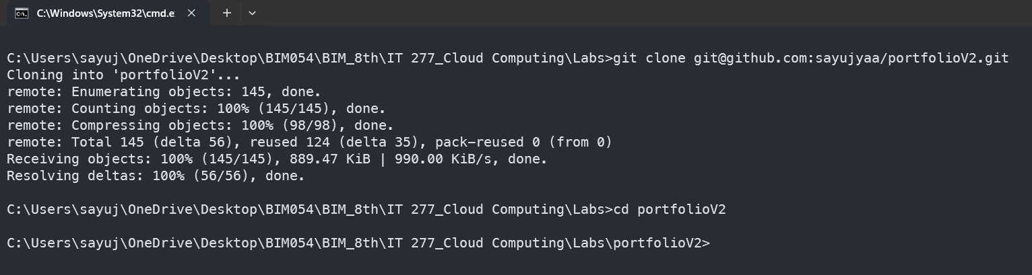
Figure 2.1 Project clone and move

Part 2: Create Dockerfile
Step 1: Create Dockerfile
Inside the React project directory, create a file named: Dockerfile

Step 2: Add Dockerfile Content
Example Dockerfile using Nginx:
FROM node:18 AS build
WORKDIR /app
COPY . .
RUN npm install
RUN npm run build
FROM nginx:latest
COPY --from=build /app/dist /usr/share/nginx/html
EXPOSE 80
CMD ["nginx", "-g", "daemon off;"]

Explanation:
- The first stage builds the React application.
- The second stage uses Nginx to serve the production build.

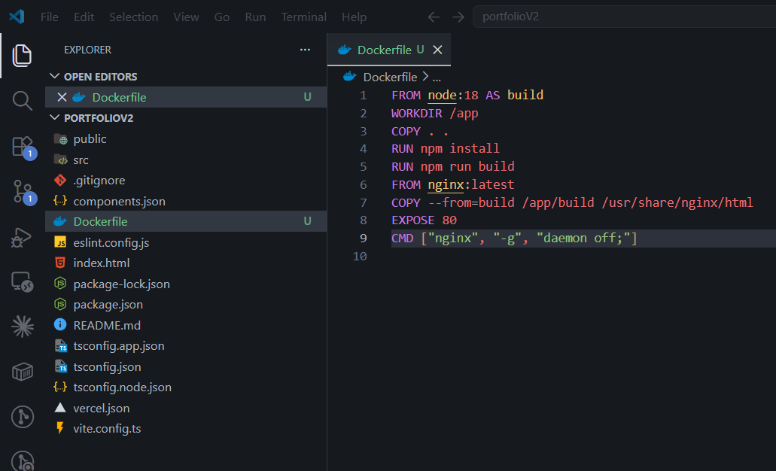
Figure 2.2 Create and add content to the docker file

Part 3: Build Docker Image
Step 1: Build Docker Image
Run the following command:
docker build -t sayujya-react .

Explanation:
- `docker build` creates the Docker image.
- `-t` assigns a tag or image name.
- `.` indicates the current project directory.

Step 2: Verify Image
Run:
docker images

This displays the list of available Docker images.
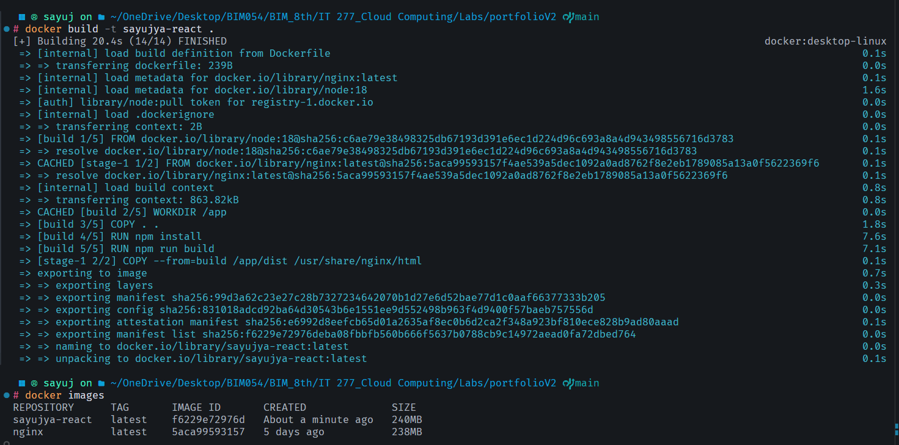
Figure 2.3 Add Dockerfile and create docker image

Part 4: Run Docker Container
Step 1: Run Container
Run the following command:
docker run -d -p 8081:80 sayujya-react

Explanation:
- `-d` runs the container in detached mode.
- `-p 8080:80` maps local port 8080 to container port 80.

Step 2: Verify Running Container
Run:
docker ps

This shows all running containers.
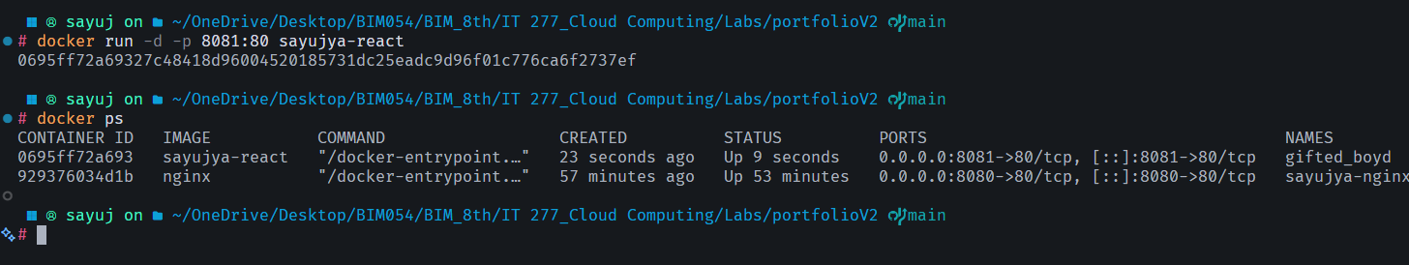
Figure 2.4 Running the docker container

Part 5: Test React Application
Open a web browser and visit: http://localhost:8081
The React application should load successfully.
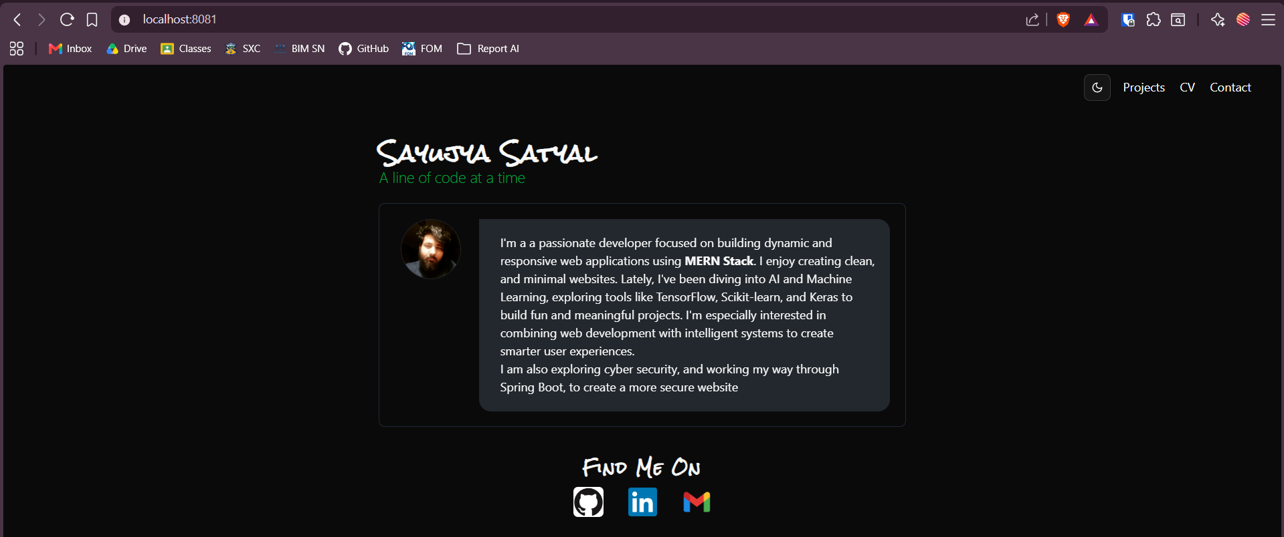
Figure 2.5 React application hosting successfully

Part 6: Push Docker Image to Docker Hub
Step 1: Login to Docker Hub
Run: docker login and ensure you are logged in inside the docker desktop app.

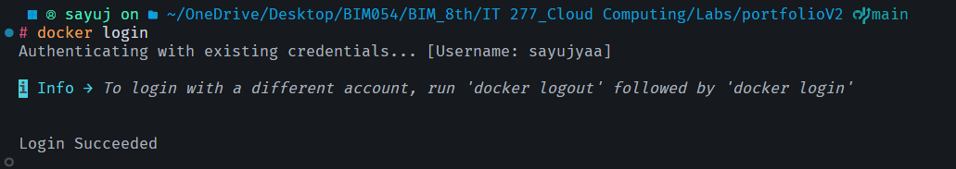
Figure 2.6 Successful Login with Docker

Step 2: Tag Docker Image
Run: docker tag sayujya-react sayujyaa/sayujya-react:latest
Explanation:
- Tags the local image for Docker Hub upload.
Figure 2.7 Successful tag of docker image

Step 3: Push Docker Image
Run: docker push sayujyaa/sayujya-react:latest
Explanation:
- Uploads the Docker image to Docker Hub registry.
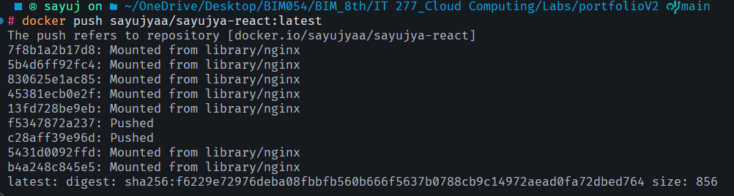
Figure 2.8 Successful push of docker image

Result
The React project was successfully dockerized using Docker and Nginx. The Docker image was built, executed locally, and pushed successfully to Docker Hub.

Conclusion
This lab provided practical experience in containerizing a React application using Docker. The experiment demonstrated how Docker simplifies application deployment, portability, and distribution using Docker Hub.

LAB ASSIGNMENT 3: ORACLE VM VIRTUALBOX INSTALLATION WITH UBUNTU SERVER 26.04 AND AAPANEL DEPLOYMENT

Objective
The objective of this lab is to:
- Install Oracle VM VirtualBox.
- Install Ubuntu Server 26.04 without GUI.
- Configure NAT networking and static IP address.
- Enable SSH access from VS Code terminal.
- Install aaPanel and Nginx web server.
- Configure firewall rules for required ports.
- Access and test the aaPanel dashboard through the browser.

Theory
- Oracle VM VirtualBox: Oracle VM VirtualBox is a virtualization software used to create and manage virtual machines. It allows multiple operating systems to run on a single physical computer.
- Ubuntu Server: Ubuntu Server is a Linux-based operating system designed for servers and cloud environments. Unlike Ubuntu Desktop, it does not include a graphical interface and is optimized for command-line administration.
- NAT Networking: NAT (Network Address Translation) networking allows the virtual machine to access external networks using the host system’s internet connection while remaining isolated from the external network.
- SSH (Secure Shell): SSH is a secure network protocol used for remote access and command-line management of Linux servers.
- aaPanel: aaPanel is a lightweight hosting control panel used for managing websites, databases, FTP services, and web servers such as Nginx and Apache.

Requirements
- Oracle VM VirtualBox
- Ubuntu Server 26.04 ISO
- Stable internet connection
- VS Code with SSH extension
- Minimum 4 GB RAM
- Minimum 25 GB Storage

Part 1: Install Oracle VM VirtualBox
- Visit the official VirtualBox website: https://www.virtualbox.org/
- Download the installer for your operating system.
- Run the installer and complete the installation process using default settings.
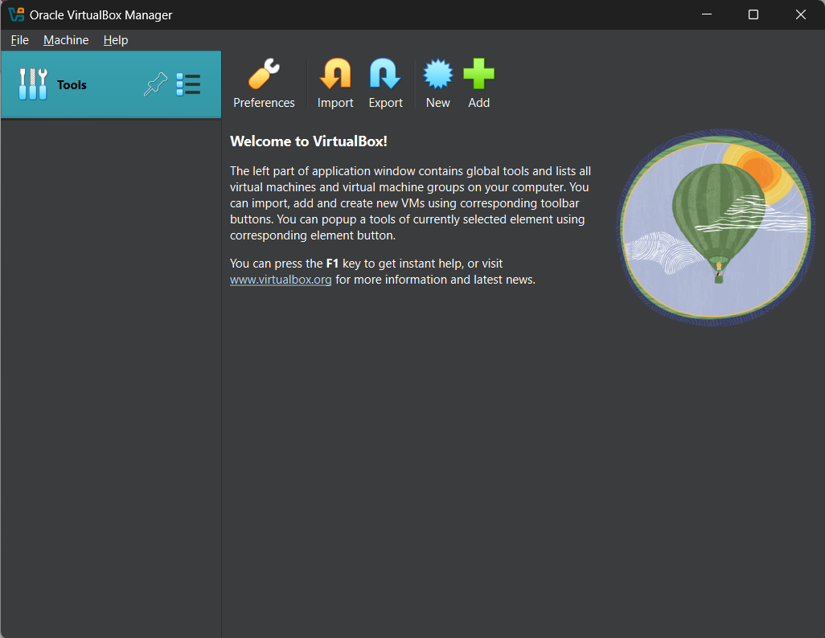
Figure 3.1 Virtualbox after successful installation

Part 2: Install Ubuntu Server 26.04
Step 1: Download the Ubuntu Server ISO file
- Visit the official Ubuntu Server website: https://ubuntu.com/download/server
- Download Ubuntu Server 26.04 ISO image.
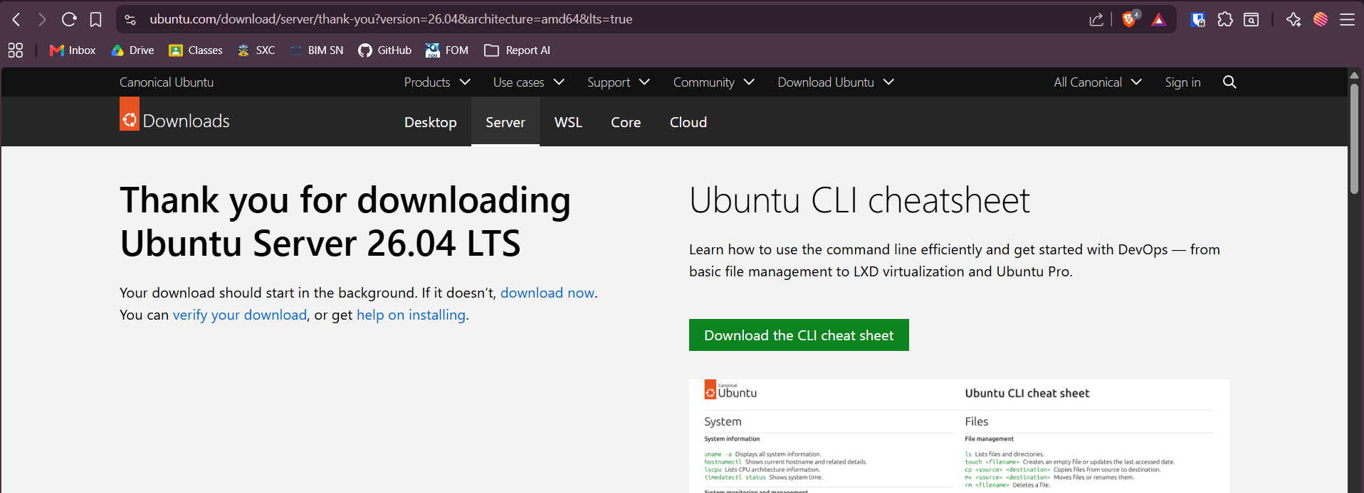
Figure 3.2 Downloading the ubuntu server 26.04

Step 2: Create New Virtual Machine
- Open VirtualBox and click on “New”.
- Configure:
- Name: Ubuntu Server
- Type: Linux
- Version: Ubuntu (64-bit)
- Allocate:
- RAM: 4096 MB
- Processors: 6 CPUs
- Storage: 25 GB dynamically allocated
- Attach the Ubuntu Server ISO file.

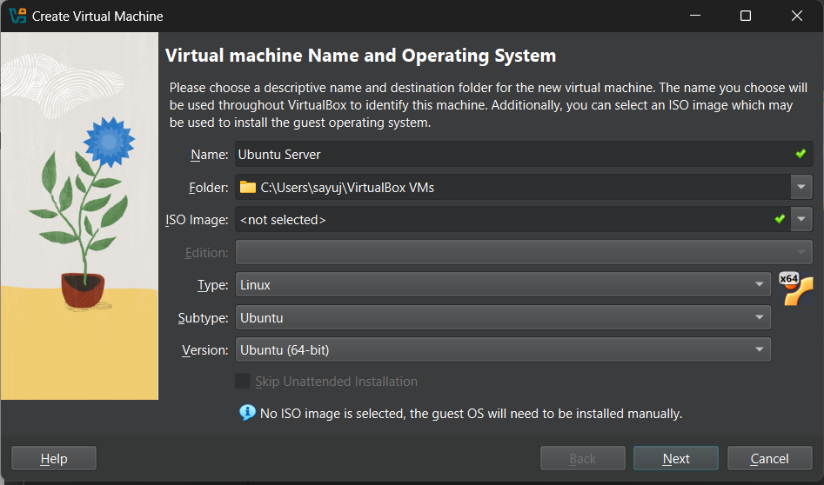
Figure 3.3 Configuring the VM name
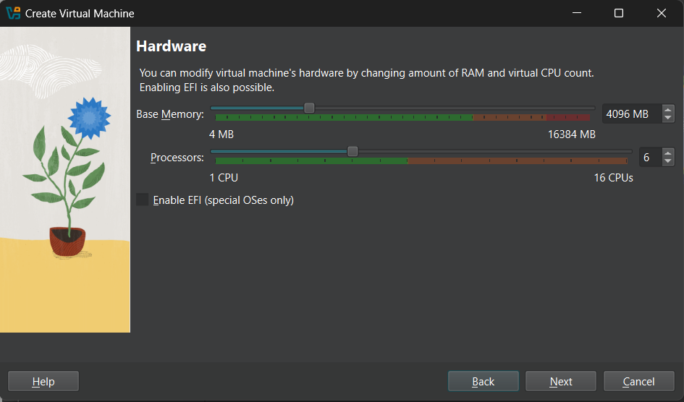
Figure 3.4 Allocating Memory and CPU
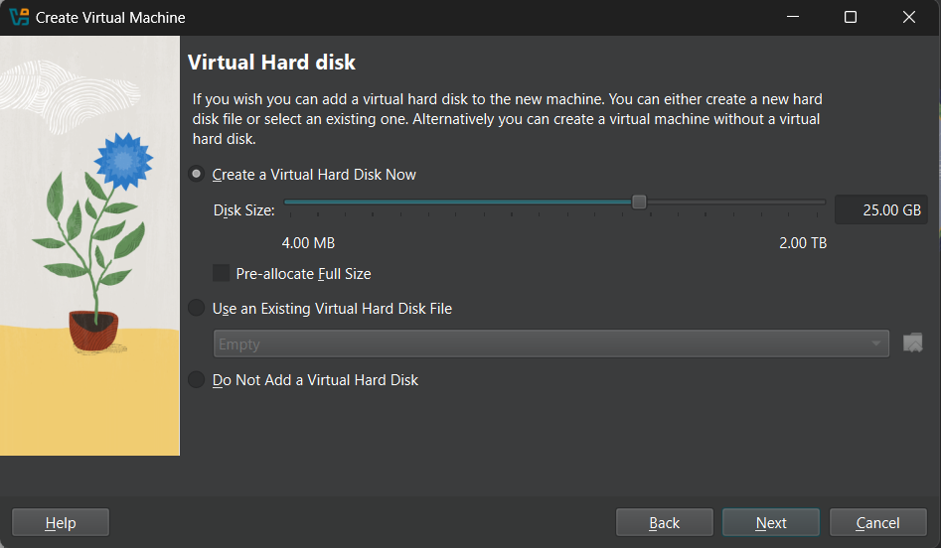
Figure 3.5 Allocating Disk Size
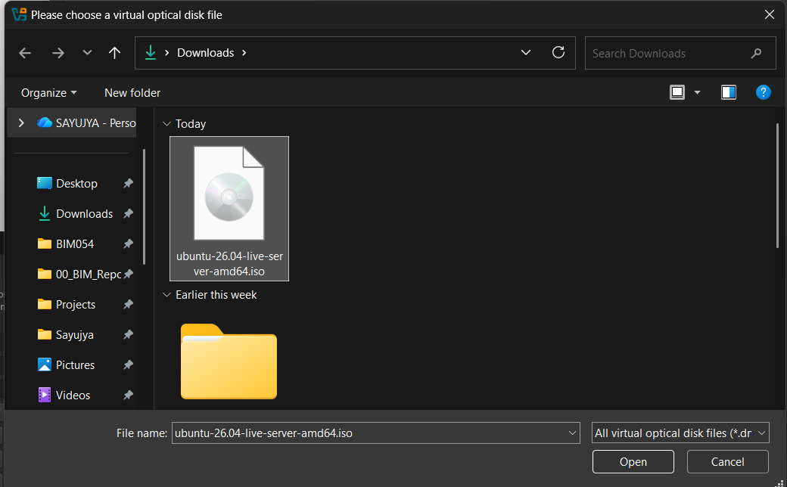
Figure 3.6 Attaching the ubuntu iso

Step 3: Install Ubuntu Server
- Start the virtual machine and follow the Ubuntu Server installation process.
- Configure:
  - Username
  - Password
  - Hostname
- Install OpenSSH Server when prompted.
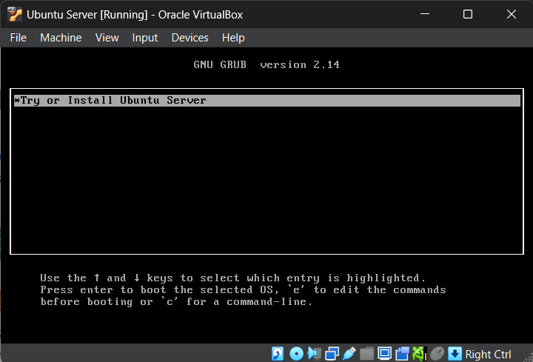
Figure 3.7 Installing Ubuntu Server
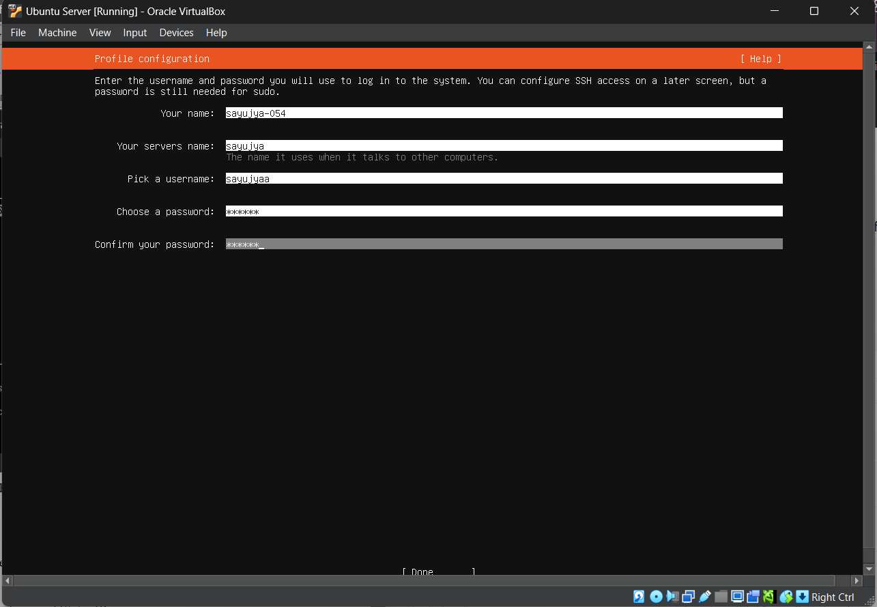
Figure 3.8 Configuration of profile in ubuntu
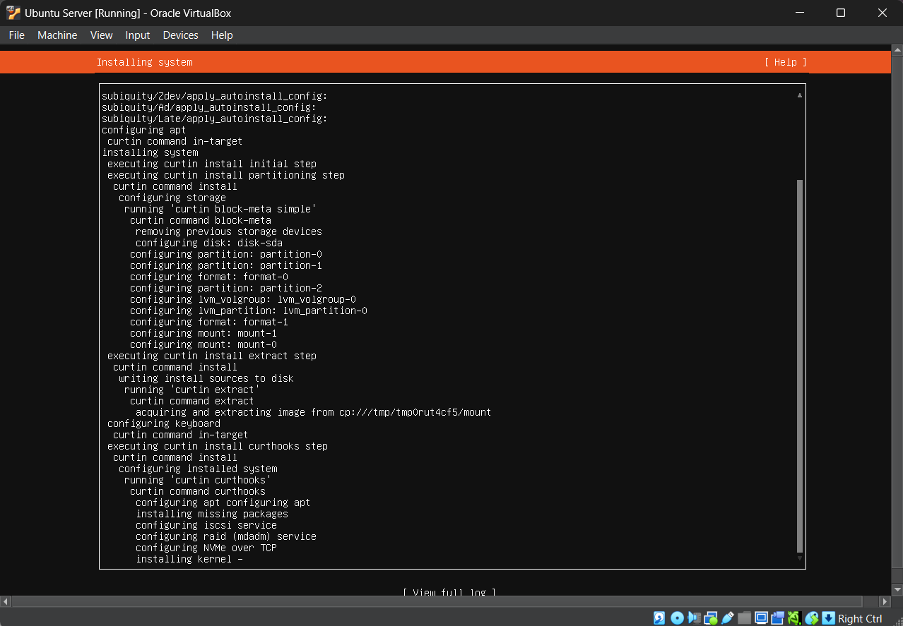
Figure 3.9 Installation Process
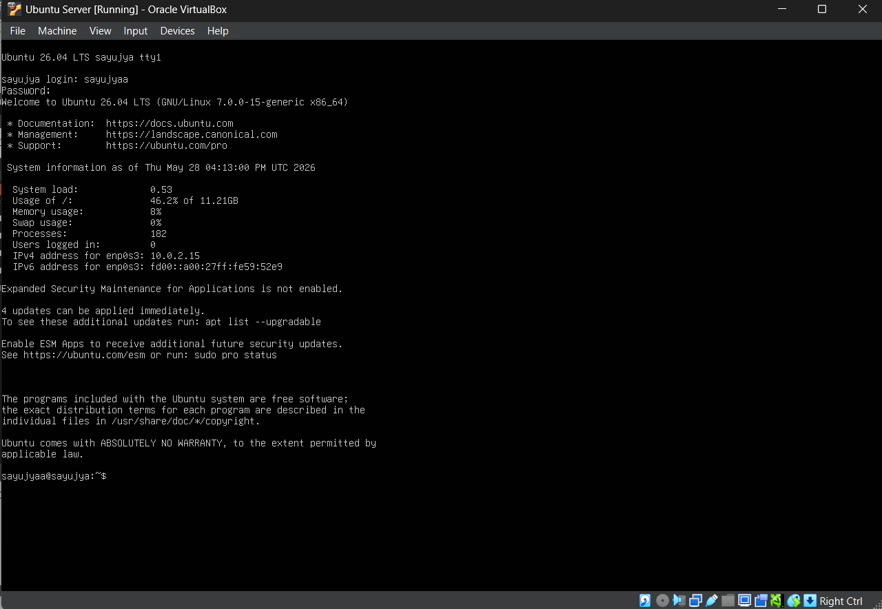
Figure 3.10 Successful login to the system

Part 3: Configure NAT Networking and Static IP
Step 1: Configure Network Adapter
Open VirtualBox Settings and then to the Network and set the Adapter 1 to NAT, and Adapter 2 to Host-only Adapter
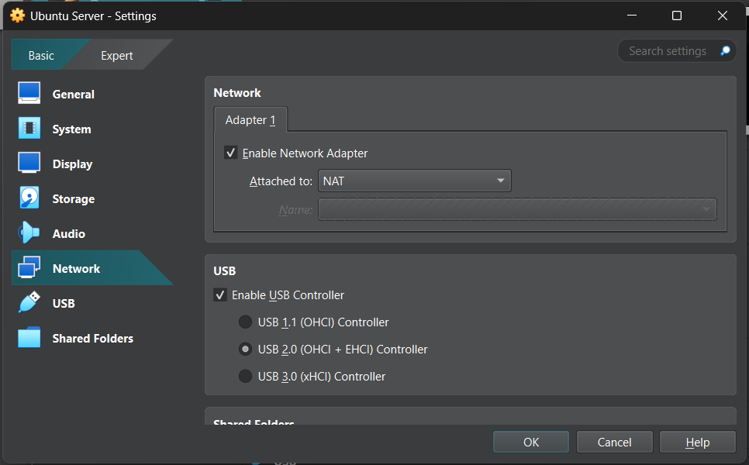
Figure 3.11 Setting network adapter 1 to NAT
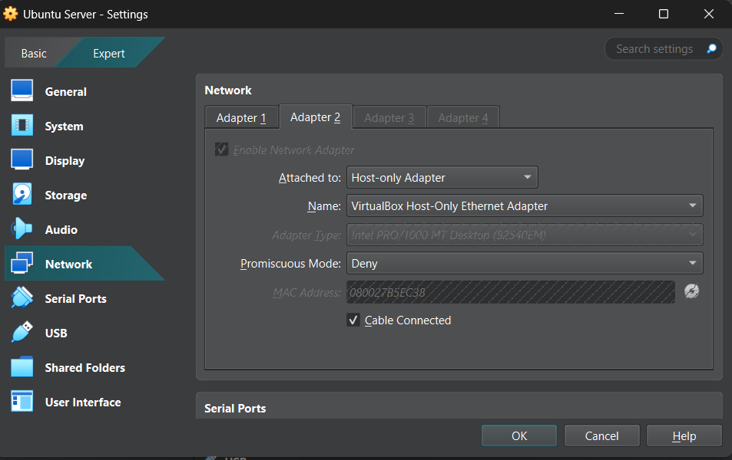
Figure 3.12 Setting Network adapter 2 to Host-only

Step 2: Configure Static IP Address
- First check the IPv4 address from the VMware Tools > Network and inside the VirtualBox Host-only Ethernet Adapter you will see IPv4 Prefix, my is 192.168.56.1/24
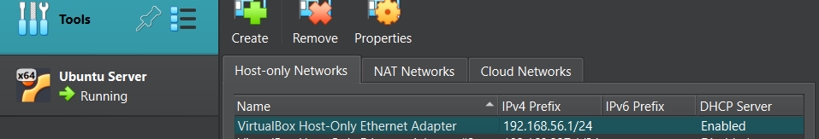
Figure 3.13 IPv4 address of VirtualBox
- Open Netplan configuration file: sudo nano /etc/netplan/00-installer-config.yaml
- Set the configurarion to:
network:
version: 2
ethernets:
enp0s3:
dhcp4: yes
enp0s8:
dhcp4: no
addresses:
  - 192.168.56.100/24

- Apply configuration: sudo netplan apply
- Verify IP address: ip a

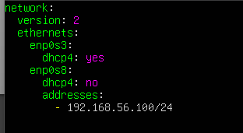
Figure 3.14 Configuration of the static IP
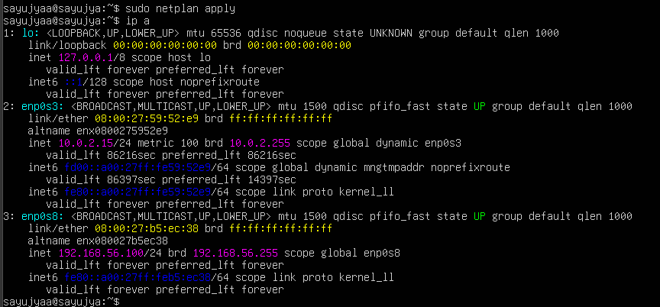
Figure 3.15 Verifying the IP address

Part 4: Configure SSH Access
Step 1: Verify SSH Service
- Check SSH status: sudo systemctl status ssh
- Enable SSH service:
sudo systemctl enable ssh
sudo systemctl start ssh

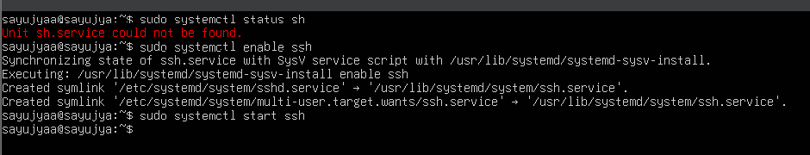
Figure 3.16 SSH configuration enable

Step 2: Connect Using VS Code
Open VS Code terminal and run: ssh root@127.0.0.1 -p 2222
Enter the server password to connect successfully.
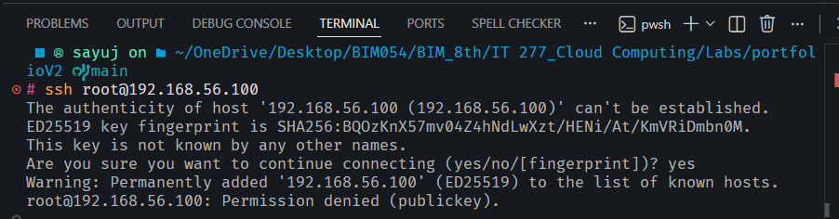
Figure 3.17 Connect to ssh using VS Code

Part 5: Install aaPanel and Nginx
Step 1: Update Ubuntu Server
Run: sudo apt update && sudo apt upgrade -y

Step 2: Install aaPanel
- Run the official aaPanel installation command:
wget -O install.sh http://www.aapanel.com/script/install_7.0_en.sh
sudo bash install.sh
sudo bash install.sh

- Wait for installation to complete.
- The installation process generates:
  - aaPanel URL
  - Username
  - Password
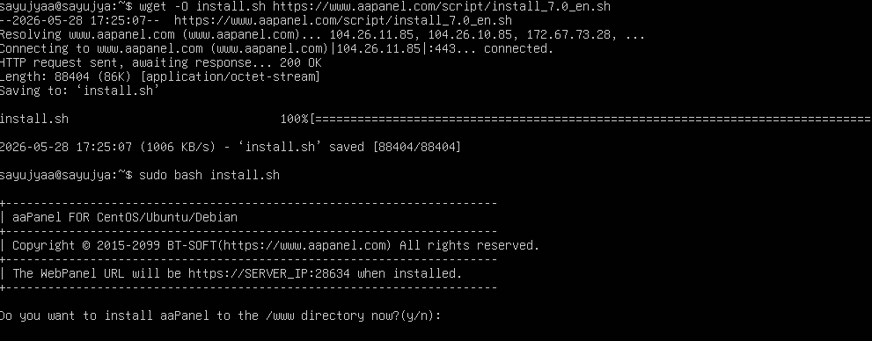
Figure 3.18 Installing aaPanel
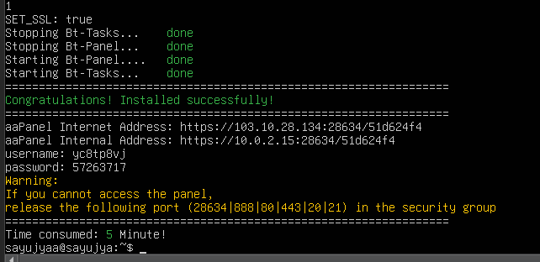
Figure 3.19 Complete installation of the aaPanel

Step 3: Install Nginx
- Run: sudo apt install nginx -y
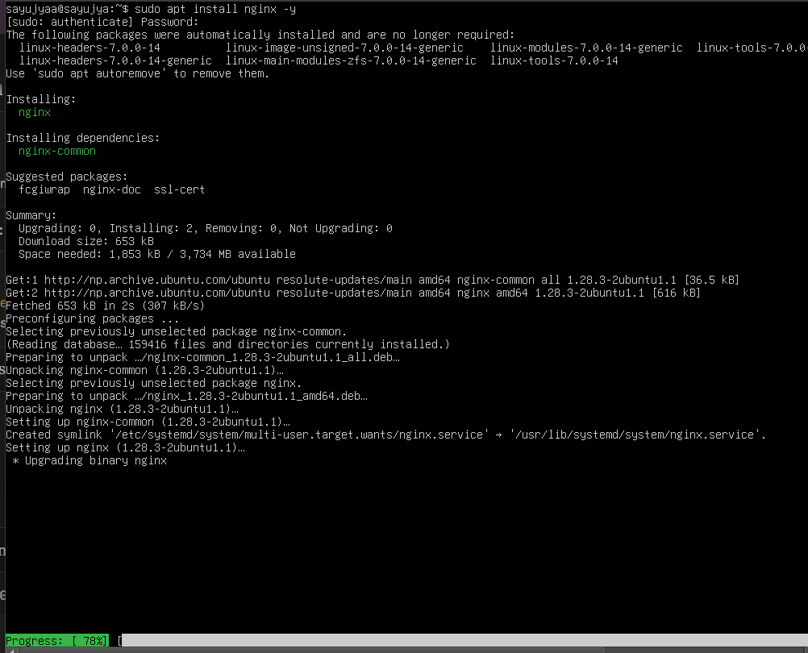
Figure 3.20 Installing Nginx

Part 6: Configure Firewall
Step 1: Allow Required Ports
- Run the following commands:
sudo ufw allow 22
sudo ufw allow 80
sudo ufw allow 8888
- Enable firewall: sudo ufw enable
- Check firewall status: sudo ufw status
Explanation:
- Port 22 → SSH
- Port 80 → HTTP
- Port 8888 → aaPanel Dashboard
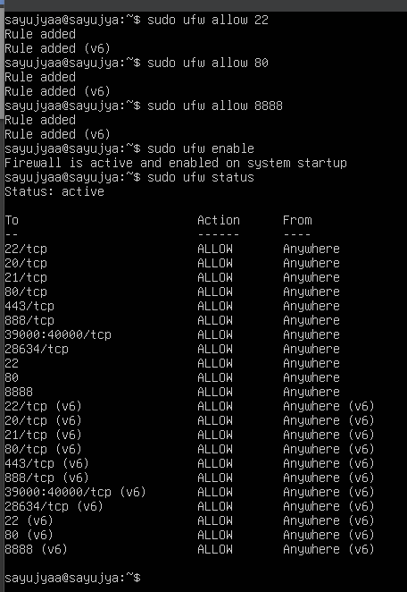
Figure 3.21 Setup firewall

Part 7: Access aaPanel Dashboard
- Open browser and visit: http://192.168.56.100:28634/51d624f4 (The IP is the same one used in the ssh one)
- Login using the credentials generated during installation.
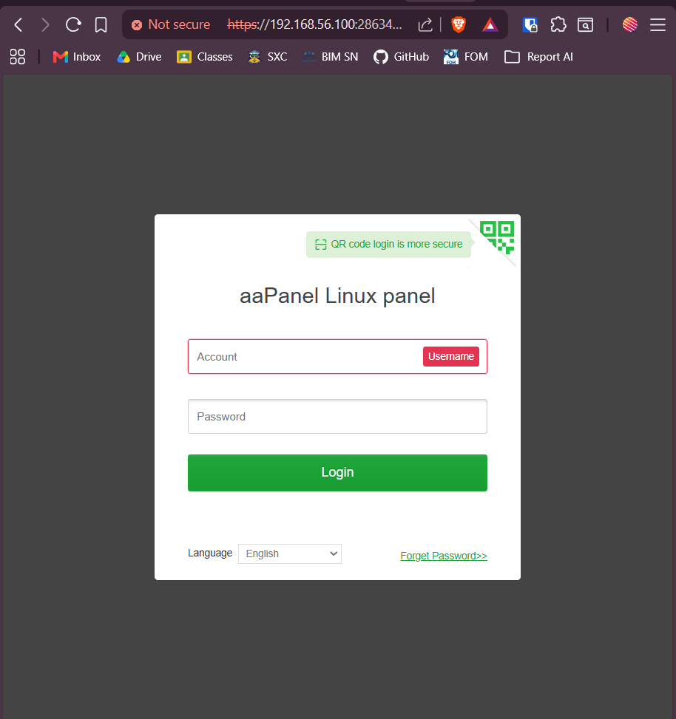
Figure 3.22 The aaPanel login
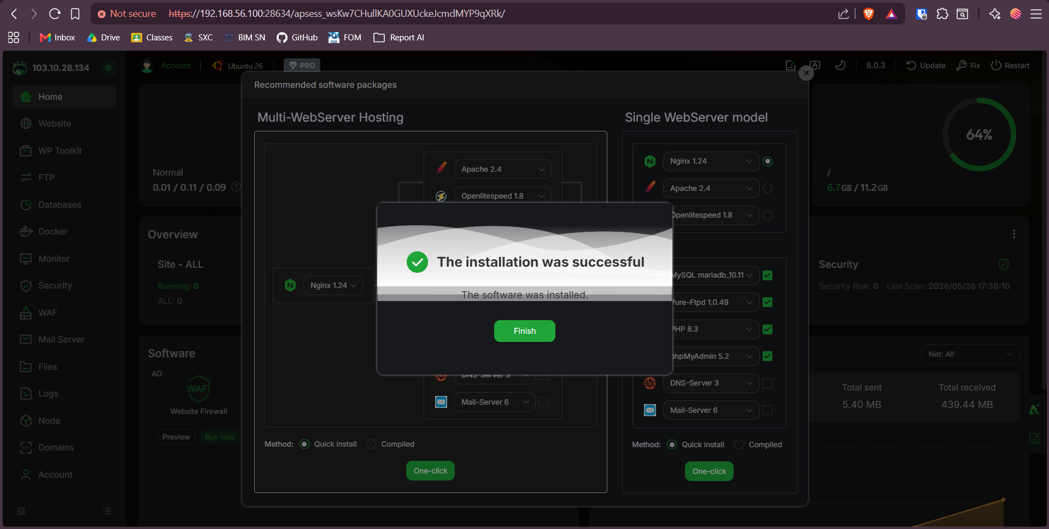
Figure 3.23 Successful aaPanel login

Part 8: Verify Nginx Deployment
- Open browser and visit: http://192.168.56.100
- The default Nginx welcome page should appear.
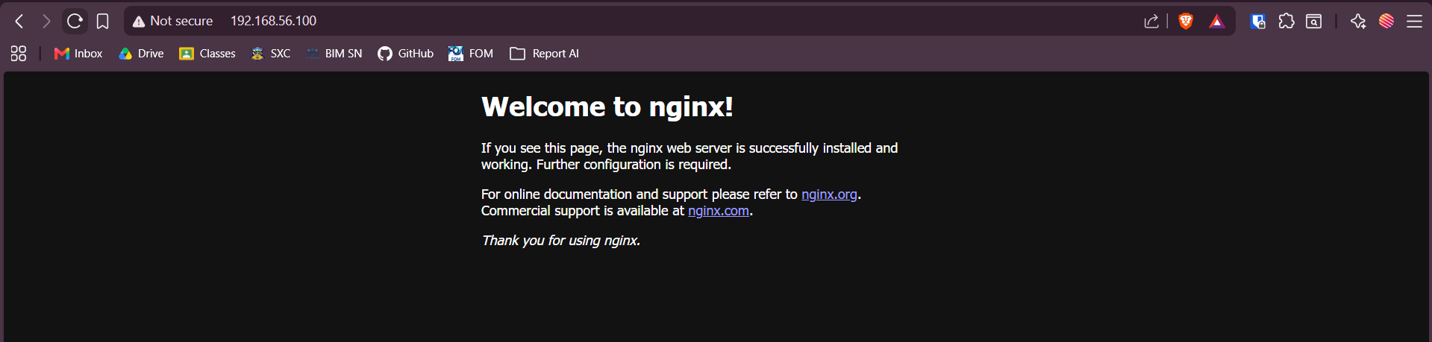
Figure 3.24 Default Nginx page

Result
Oracle VM VirtualBox and Ubuntu Server 26.04 were successfully installed. NAT networking and static IP configuration were completed successfully. SSH access was established using VS Code terminal. aaPanel and Nginx were installed and configured successfully, and the dashboard was accessible through the browser.

Conclusion
This lab provided practical experience in server virtualization, Linux server administration, SSH remote access, firewall management, and web hosting panel deployment. The experiment demonstrated how cloud and server infrastructure can be managed using virtualization technologies and Linux-based hosting environments.

